Wholesale Retail Performance Analytics : Sales, Customers, Products & Returns

1. Project Overview -
This project delivers an end to end analytics solution for a UK based wholesale retail business. Using real transactional data from the Online Retail II dataset, the analysis covers the full spectrum of business performance i.e sales trends, customer behavior, product performance, return patterns, and geographic insights.
The objective was to transform raw retail data into clear, actionable intelligence using a modern analytics stack. The project includes:
- Data Cleaning & Preparation in Python (Pandas, NumPy)
- Data Modeling & SQL Analysis in PostgreSQL
- Interactive BI Dashboards developed in Tableau
- Business Insights & Strategic Recommendations for operations, sales, and customer retention
The outcome is a consolidated, 360 degree view of the business that supports better decision-making across inventory planning, customer engagement, product strategy, and operational efficiency. The report and dashboards are designed so that both technical and non-technical stakeholders can quickly understand performance patterns, identify problem areas, and act on clear recommendations.

2. Business Problem & Objective -
The company is a UK based wholesale retailer selling gift, decor, and seasonal products to small shops and resellers. Despite having years of transactional data, the business lacked a unified view of its performance. Key challenges included:
- No clear understanding of sales seasonality and monthly revenue behaviour
- Limited visibility into customer retention, repeat buying, and revenue concentration
- Unclear performance of individual products and SKUs
- Rising returns with no breakdown of why they were happening
- Uneven performance across countries and regions
- No centralized reporting for leadership to make quick, data-backed decisions
These gaps led to inefficient inventory planning, missed revenue opportunities, poor customer targeting, and operational blind spots.

2.2 Objective -
The objective of this project was to conduct a complete end to end analysis of the business using the available sales dataset and deliver:
- A clear understanding of sales performance
- Deep insights into customer behaviour and loyalty
- Detailed product level analysis to identify winners, weak items, and operational risks
- A breakdown of return patterns and their financial impact
- Country level insights to support market strategy and logistics improvements
- A full suite of interactive dashboards for ongoing monitoring
The final outcome is a structured, business ready analysis designed to help leadership make informed decisions across revenue planning, customer engagement, product strategy, and operational efficiency.

3. Data Preparation & Cleaning Summary -
The dataset contained over 1 million transactional records across invoices, products, customers, pricing, and timestamps. Before analysis, the data went through a structured cleaning process to ensure accuracy and business consistency.

Key Cleaning Steps :

i. Structural Fixes
- Standardized column names
- Corrected data types (dates, numeric fields, customer IDs)
- Cleaned product descriptions for consistency

ii. Business Logic Corrections
- Flagged cancelled invoices (Invoice starting with “C”)
- Identified returned items (negative quantities)
- Labeled guest customers (missing customer IDs)
- Marked non-product codes (fees, postage, samples)
- Removed invalid price records (negative price errors)

iii. Validity Filtering
Only 2,750 corrupted rows were removed (0.2%), ensuring all genuine sales, returns, and cancellations remained intact.

iv. Derived Columns for Analysis
- Total revenue per line item
- Date breakdown (Year / Month / Day / Hour)
- Country groupings (UK vs Non-UK)

v. Final Dataset
The cleaned, analysis-ready dataset contained:
- 1,064,621 rows
- Full integrity of all sales, returns, and operational events
- 20 enriched fields supporting deeper analytics
The dataset was then modeled into PostgreSQL for SQL analysis and connected to Tableau for dashboard development.

4. Key Insights From SQL Analysis -
The analysis was divided into five major business areas: Revenue, Customers, Products, Returns, and Geography. Each category revealed clear patterns that help explain the company’s performance.
4.0 Key Business Metrics
- Total Revenue Analyzed : £20.97M
- Total Units Sold : 11.4M+ units
- Registered Customers : 5,939
- Guest Orders : 240K+ (anonymous transactions)
- Average Order Value (AOV) : £523
- Revenue Loss Due to Returns : 7.28%

4.1 Revenue Insights
- Revenue is highly seasonal, peaking during Q3–Q4 due to holiday demand and bulk restocking by retailers.
- Months leading into the holiday season show a steady upward trend, while Q1 and early Q2 drop sharply as retailers reduce stock.
- The company operates on a low margin, high volume model, reflected in a low AOV of £ 523 and millions of units sold.
- Most purchases happen between 10 AM – 3 PM, aligning with retailers’ restocking hours.

4.2 Customer Insights
- The business has 5,939 registered customers, but over 240,000 orders came from guest buyers.
- The repeat purchase rate is 72%, showing strong loyalty and predictable restocking behavior.
- The company is revenue heavy on top customers:
  - Top 1% contributes to 32% of revenue
  - Top 10% contributes to 64% of revenue
  - Top 20% contributes to 77% of revenue
- Active customers spike in September & November due to holiday preparation.

4.3 Product Insights
- Best selling products are small, low cost decorative items, supporting the “high volume” business model.
- High revenue Products include premium or larger products like cake stands and bags.
- Multiple dead Products (near zero sales) indicate inefficient inventory carrying.
- Fragile and electrical items show high return rates, pointing to quality or packaging issues.

4.4 Return Insights
- Overall unit return rate is 9.3%, and return related revenue loss is ~7.28% i.e around 1.53 million GBP.
- Return spikes appear in mid-year (post-holiday unsold stock) and Q4 (transit and operational errors).
- A few customers show abnormally high return percentages (100–300%), indicating internal data entry errors.
- Fragile items, sample stockcodes, and fee related rows dominate the return list.

4.5 Geographic Insights
- The UK dominates revenue and customer volume, as expected for a UK based wholesaler.
- Nearby European countries also show strong contribution due to quick shipping and similar holiday cycles.
- Distant markets (USA, UAE, Korea, Nigeria) have higher return rates, mainly because longer transit increases damage risk.
- The company’s international presence is limited, leaving growth potential outside Europe.

5. Dashboards -
i. Business Performance Executive Overview : This dashboard provides a high level view of the company’s core KPIs, including revenue, units sold, customer activity, and return behavior.
It serves as a quick health check for leadership to understand overall business performance at a glance.
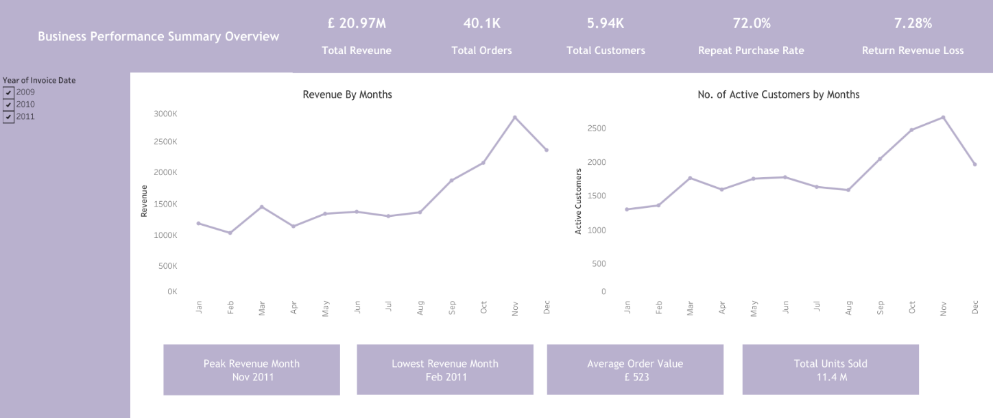

ii. Sales & Revenue Performance Intelligence : This dashboard highlights monthly, quarterly, and seasonal revenue trends along with AOV, sales peaks, and buying behavior.
It helps identify demand cycles, slow periods, and overall revenue dynamics across time.
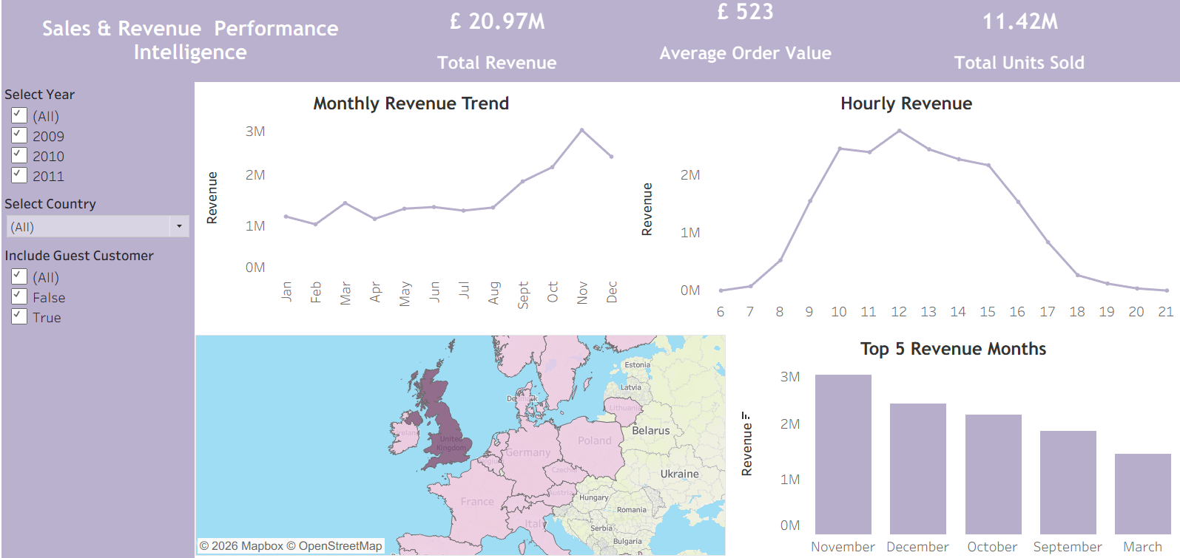

iii. Geographic Sales & Market Distribution Analysis : This dashboard breaks down revenue, customer volume, and return patterns across countries and regions.
It reveals strong-performing markets, weak geographies, and logistics-related return hotspots.
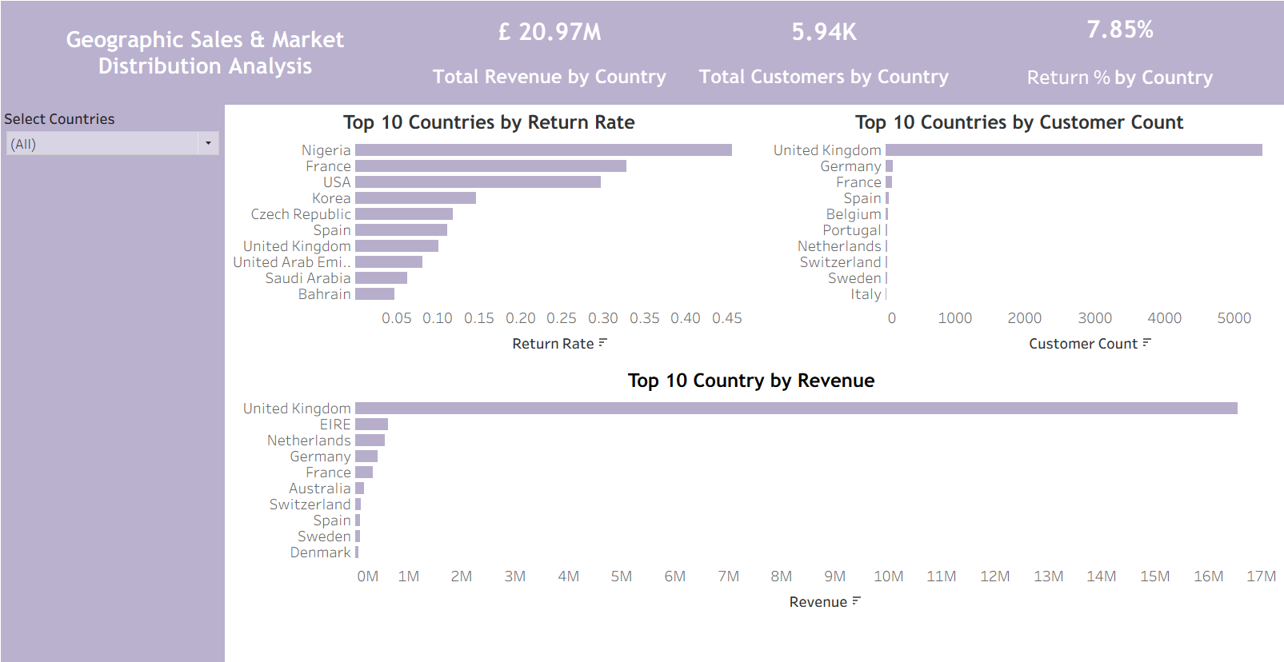
iv. Product Portfolio Performance & SKU Optimization : This dashboard analyzes top selling items, high revenue SKUs and products driving returns.
It supports better inventory planning, SKU rationalization, and product strategy decisions

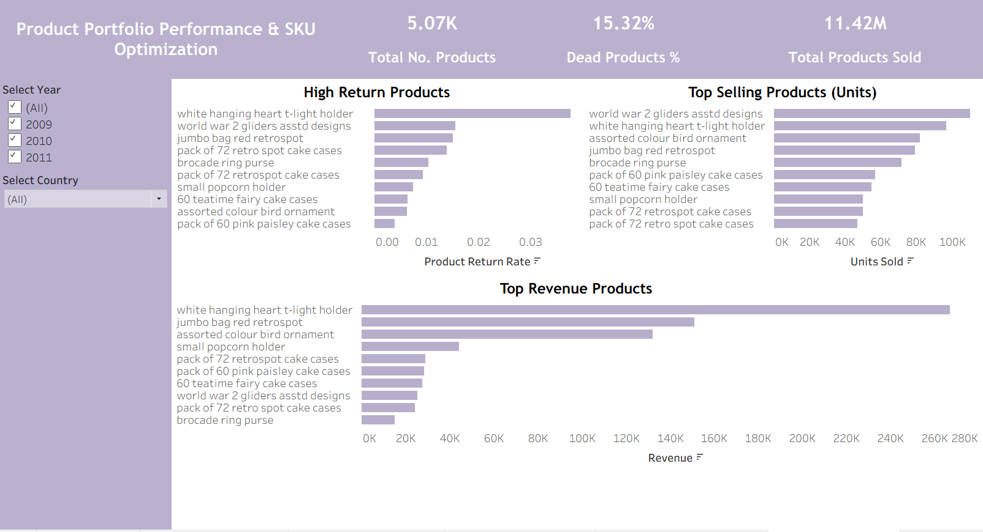

v. Customer Lifecycle, Segmentation & Behavioral Insights : This dashboard explores new vs returning customers, monthly active customers, top customer contributions, and loyalty patterns.
It uncovers retention behavior and identifies customer groups critical for revenue growth.

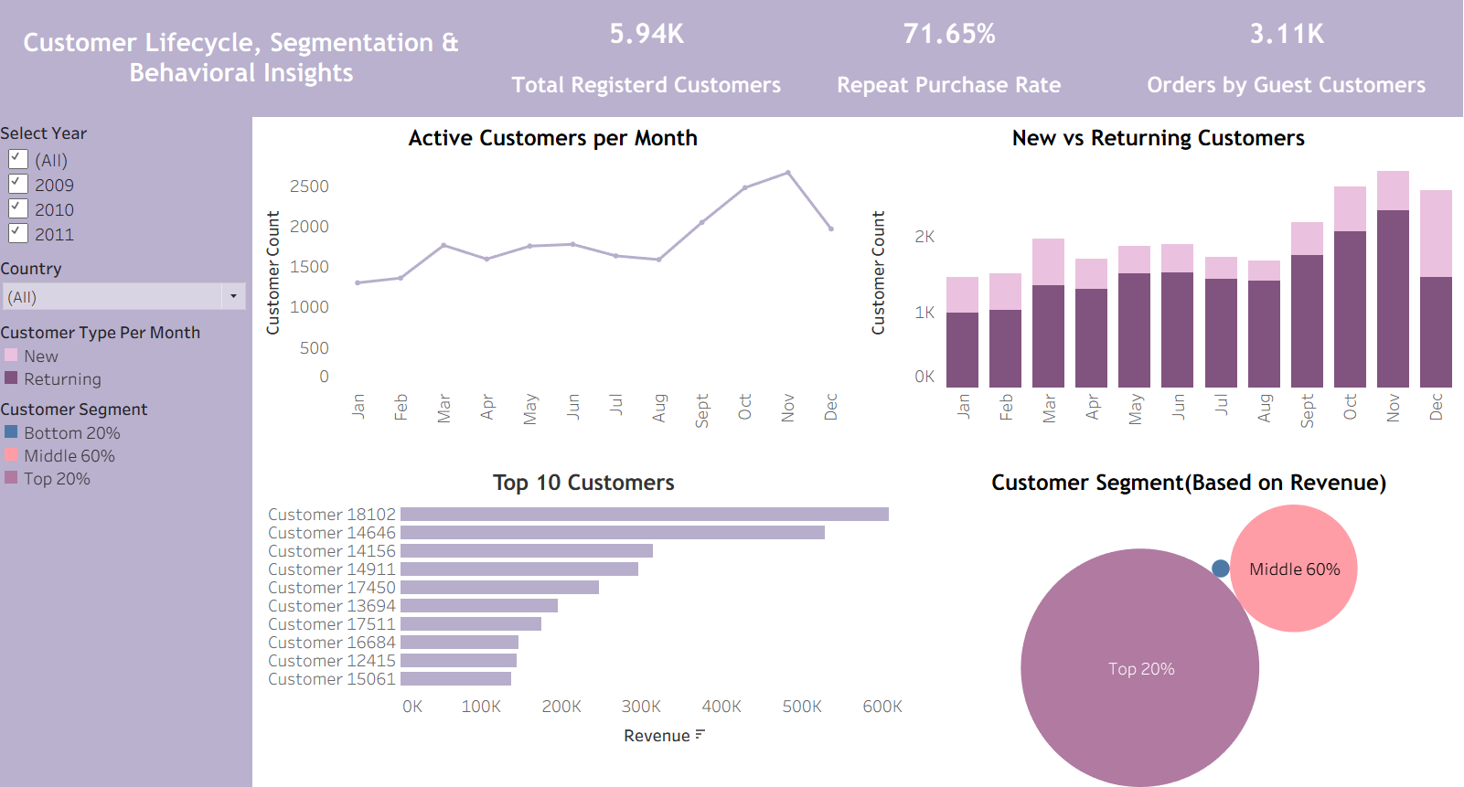

vi. Returns, Quality Control & Reverse Logistics Analysis : This dashboard focuses on return volumes, return rates, contributing products, and impacted countries.
It highlights operational inefficiencies, quality issues, and financial impact associated with returns.
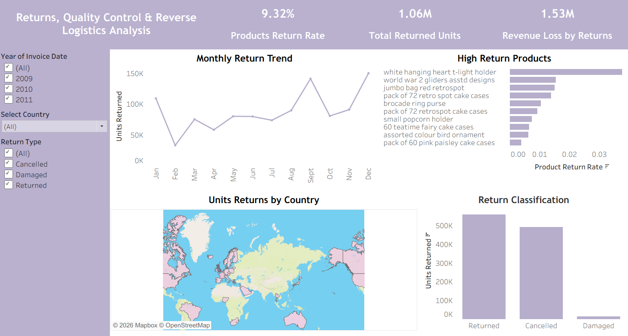

6. Key Problems Identified -
The analysis revealed several structural and operational issues that directly impact revenue, customer satisfaction, and efficiency. These problems explain why the business struggles with predictable growth and operational stability.

1. Revenue Dependency on a Small Customer Base
A disproportionate share of revenue comes from a very small group of buyers (Top 20% = 77% of revenue).
This creates a high-risk dependency — losing a few key accounts would significantly impact the business.

2. Quality & Packaging Issues Driving Returns
High return rates for fragile and electrical items indicate quality inconsistency and insufficient protective packaging, especially for long distance shipments.

3. Excessive Guest Transactions
Over 240K orders are placed by guest customers, making it difficult to track buying behavior, personalize offers, or build retention strategies.
The business loses long-term value due to anonymized buyers.

4. Inventory Inefficiency (Dead & Low-Selling SKUs)
Hundreds of products show near zero sales, tying up warehouse space and increasing storage costs without generating meaningful revenue.

5. Operational & Data-Entry Errors
Sample codes, fee codes, and incorrect return entries artificially inflate return numbers.
A few customers even show 100–300% return rates, indicating internal process errors.

6. Recommendations & Strategy -
The insights point to clear opportunities for improving revenue, customer loyalty, product performance, and operational efficiency. The following strategies address the root problems identified in the analysis.

i. Revenue & Inventory Strategy
- Strengthen inventory ahead of Q3-Q4, when demand reliably peaks.
- Reduce stock in Q1, the slowest period, to lower carrying costs.
- Introduce bundles and premium combos during high-demand months to increase AOV and margin.
- Offer controlled off-season discounts to smooth revenue dips.

ii. Customer Strategy
- Launch a loyalty and priority service program for the top 20% of customers who drive 77% of revenue.
- Convert guest buyers into registered customers through signup incentives (discount on first registered order).
- Set up automated email reminders for restocking based on historical purchase cycles.

iii. Product Strategy
- Conduct targeted quality checks for fragile and electrical items with a high return rate.
- Improve packaging standards for delicate items, especially for long distance shipping.
- Review and discontinue dead SKUs to free warehouse space and optimize the product catalog.
- Focus more on high margin items like premium cake stands, bags, and décor that already show strong revenue.

iv. Operational & Return Strategy
- Standardize internal processes to reduce incorrect return entries and “non-product code” inflation.
- Train staff or automate parts of the data entry workflow to minimize manual errors.
- Implement a Quality Check before dispatch checkpoint to prevent low quality items from reaching customers.
- Closely track return reasons in future systems to pinpoint operational gaps more accurately.

v. Geography & Market Expansion Strategy
- Strengthen the business presence in nearby European countries, where logistics, demand patterns, and seasonality match the UK market.
- For long-distance markets (USA, UAE, Korea, Nigeria), enhance packaging and evaluate customized shipping guidelines with carriers.
- Explore untapped regions with similar gift/holiday cycles once operational issues are stabilized.
This strategy aligns directly with the operational and commercial issues uncovered in the analysis and provides a practical roadmap for improving revenue, retention, and efficiency.

7. Conclusion -
This end-to-end analytics project provides a complete, data driven understanding of how the wholesale business performs across sales, customers, products, returns, and geographic markets. By cleaning and modeling over one million transactions, analyzing patterns through SQL, and building six focused Tableau dashboards, the project delivers a clear view of the company’s strengths and operational gaps.
The findings highlight strong seasonal revenue cycles, high dependence on top customers, quality and packaging issues behind returns, and significant opportunities in both inventory optimization and market expansion. The recommendations presented offer practical, actionable steps to improve profitability, strengthen customer relationships, reduce operational waste, and scale more effectively.
The final output is a unified analytics framework that enables faster decision-making, better forecasting, and a more strategic approach to sales, products, and operations.

